**Solutions Calculator Club**

**Project Documentation**

**ALU Module**

**Registers Circuit Function**:

**Registers A and B**

A computer register is a temporary storage area for data. Registers are used to store data that is being worked on by the CPU. Registers are faster than memory, because they are closer to the CPU. There are different types of registers, including data registers, address registers, and status registers. Registers are usually numbered, so that the CPU can keep track of them.

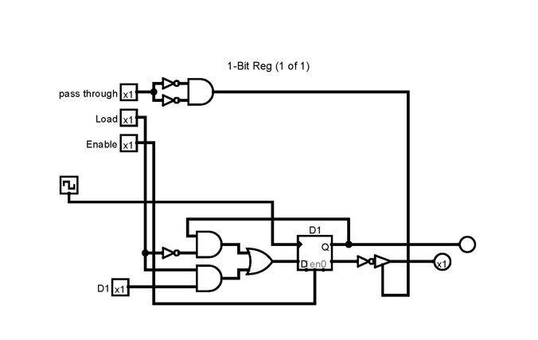

**A D FLIP FLOP 1-Bit Register with pass through**

Register A is the Accumulator and Registers B’s Value is either Subtracted or Added to Register A. Loads Data bit when the Load and Enable are High and the Clock is pulsed. The Registers in this Project are 8-bit so they Have 8 Data inputs.

**INPUTS:**

**VCC**

All of the ics in this project require 5 volt that comes from the 5 volt ac adapter. They also require ground.

**CLK IN**

Clock in triggers pin 7 on 74LS174 4-bit D Registers.

**CLR IN**

IF this signal comes in off the Data Bus pin 15 on 74LS174 4-bit D Registers will clear Data out of the Register.

**AI or BI IN**

From the Data Bus Input signals to the Data input pins (D3, D2, D1, and D0) on 74LS174 4-bit D Registers(MSB’s) Chip A and (LSB’s) Chip B.

Registers A and B Hold 8 Bit values that are either sumed or subtracted by the ALU.

Register A and B get the values off the BUS following Control Signals (RO, AI, BI). Addresses in the RAM hold stored values.

**OUTPUTS:**

**AO or BO**

If the control logic is active for AO or BO the Data Bus receives data that is passed via the 74LS245 (Octal Bus Transceiver) address lines. Which is the output of the74LS174 4-bit D Registers(MSB’s) Chip A and (LSB’s) Chip B. The BO is not used by the Control Logic, however, it can be used during testing of the Register B.

The LEDS are used to indicate the Binary Value held at that instance.

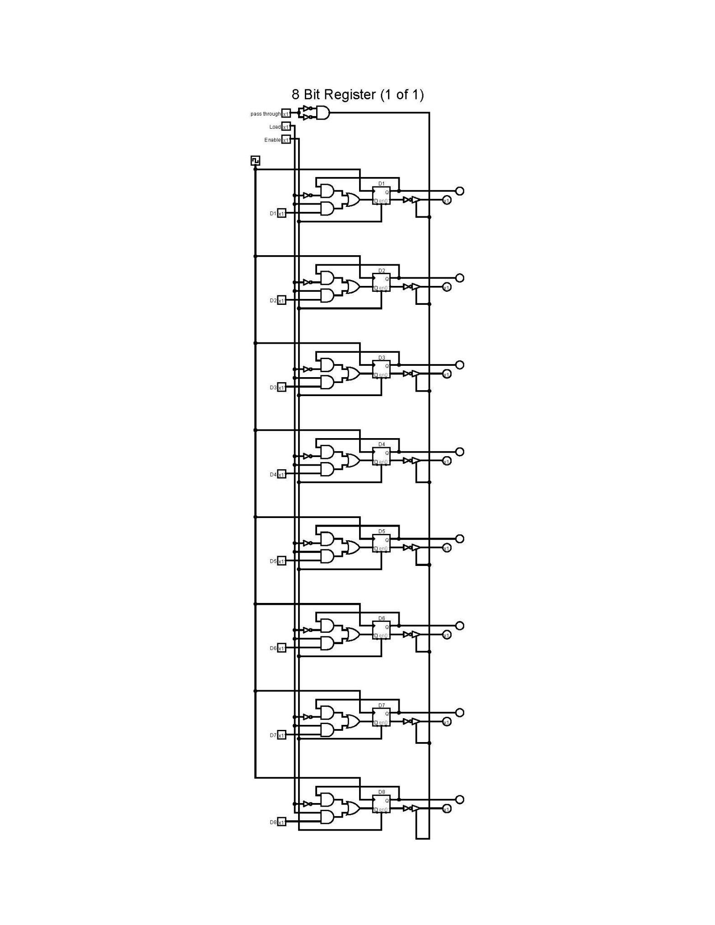

Figure of 8-Bit Register From LOGISIM File

**ALU Module Circuit Function**:

The Arithmetic and Logic Unit (ALU) is a component in a computer that takes in binary numbers and performs calculations. The ALU has two inputs and one output. The two inputs are the A and B registers, which are 8-bit memory registers that temporarily store and manipulate values. The output is the sum of the two inputs.

The ICs in the ALU have some pins that are active through Control Logic the “WORDS”

Are 2-bit values. The are the Chip IO signals like !EO, !SUB or!FL

**NOT EO**

Into CE (Chip Enable) of 74LS245 (Octal Bus Transceiver)

**SUB IN**

74LS86 (Quad XOR gate)

Control signals for subtraction operation feed into the second inputs of the 2 74LS86 XOR ICs from pin 7 Carry OUT of the LSB 4-Bit Adder.

Address lines from Register B (B_0 to B_7) feed into the inputs of 74LS86.

**OUTPUTS:**

**(EO) SUM OUT**

74LS86 (Quad XOR gate) to the MSB and LSB of the 4-Bit Adders B4-B1 inputs

Pins (9) of 74LS283 (4-Bit Adder A) to input pin14 D0 on 74LS173.

Pins (10,13,1,4) S1- S4 of 74LS283 (4-Bit Adder) to the Address lines of 74LS245 (Octal Bus Transceiver) and the inputs of 74LS02 of the Flag Register

To the Data Bus data is passed Via the 74LS245 (Octal Bus Transceiver Chip) address lines. Which the output of the 2 4 Bit Adder (MSB’s) Adder A and (LSB’s) Adder B.

the carry.

LEDs indicate what data is going out on the bus when Control signals EO (SUM OUT).

The limit of the ALU can handle a zero sum with the Zero Flag. However, a negative value can only be displayed by toggle the OUTPUT display to 2’s Complement. The minimum value is -128 to + 127. In the normal Binary conversion setting the minimum is 0 the maximum is 255.

The other operation is add this simply sums the A Bit with the B Bit rippling the carries to the next bits. If the MSB ends up with a carry overflow bit the Flag Register will show

The ALU takes the value of Register B and performs one of two operations to the value held in Register A. If the operation is Subtraction The B Reg value is XORed with the value of pin 7 on the carry out the LSB on the (B) 4Bit ADDER.

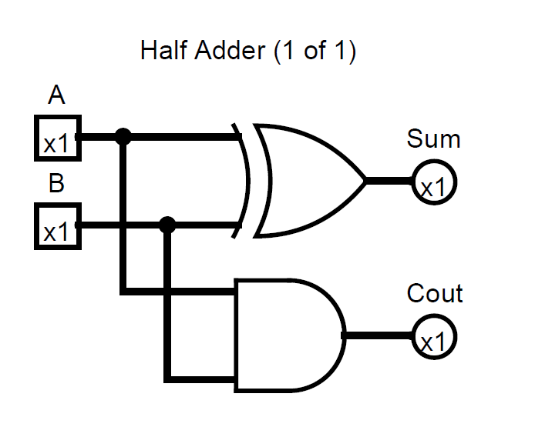

Figure from LOGISIM File

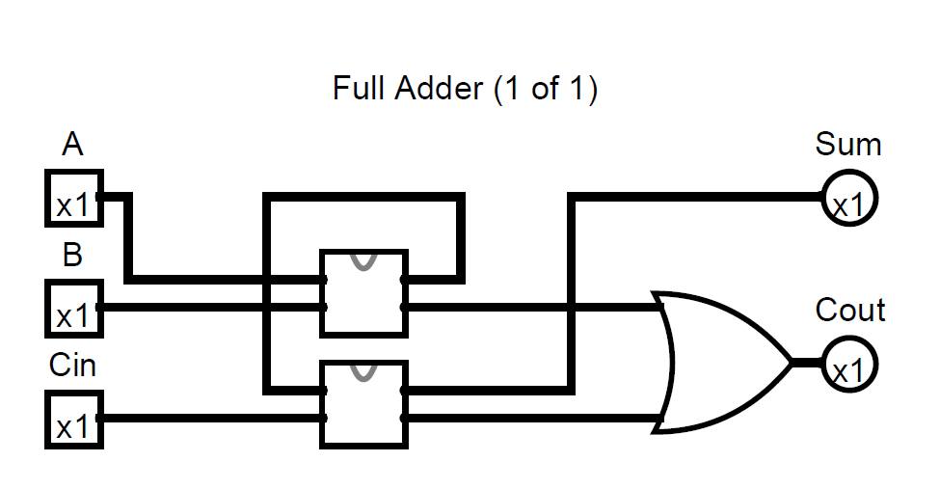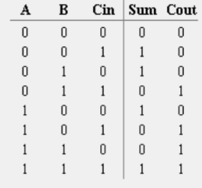

Figure From LOGISIM File

Truth Table 8-Bit Full ADDer

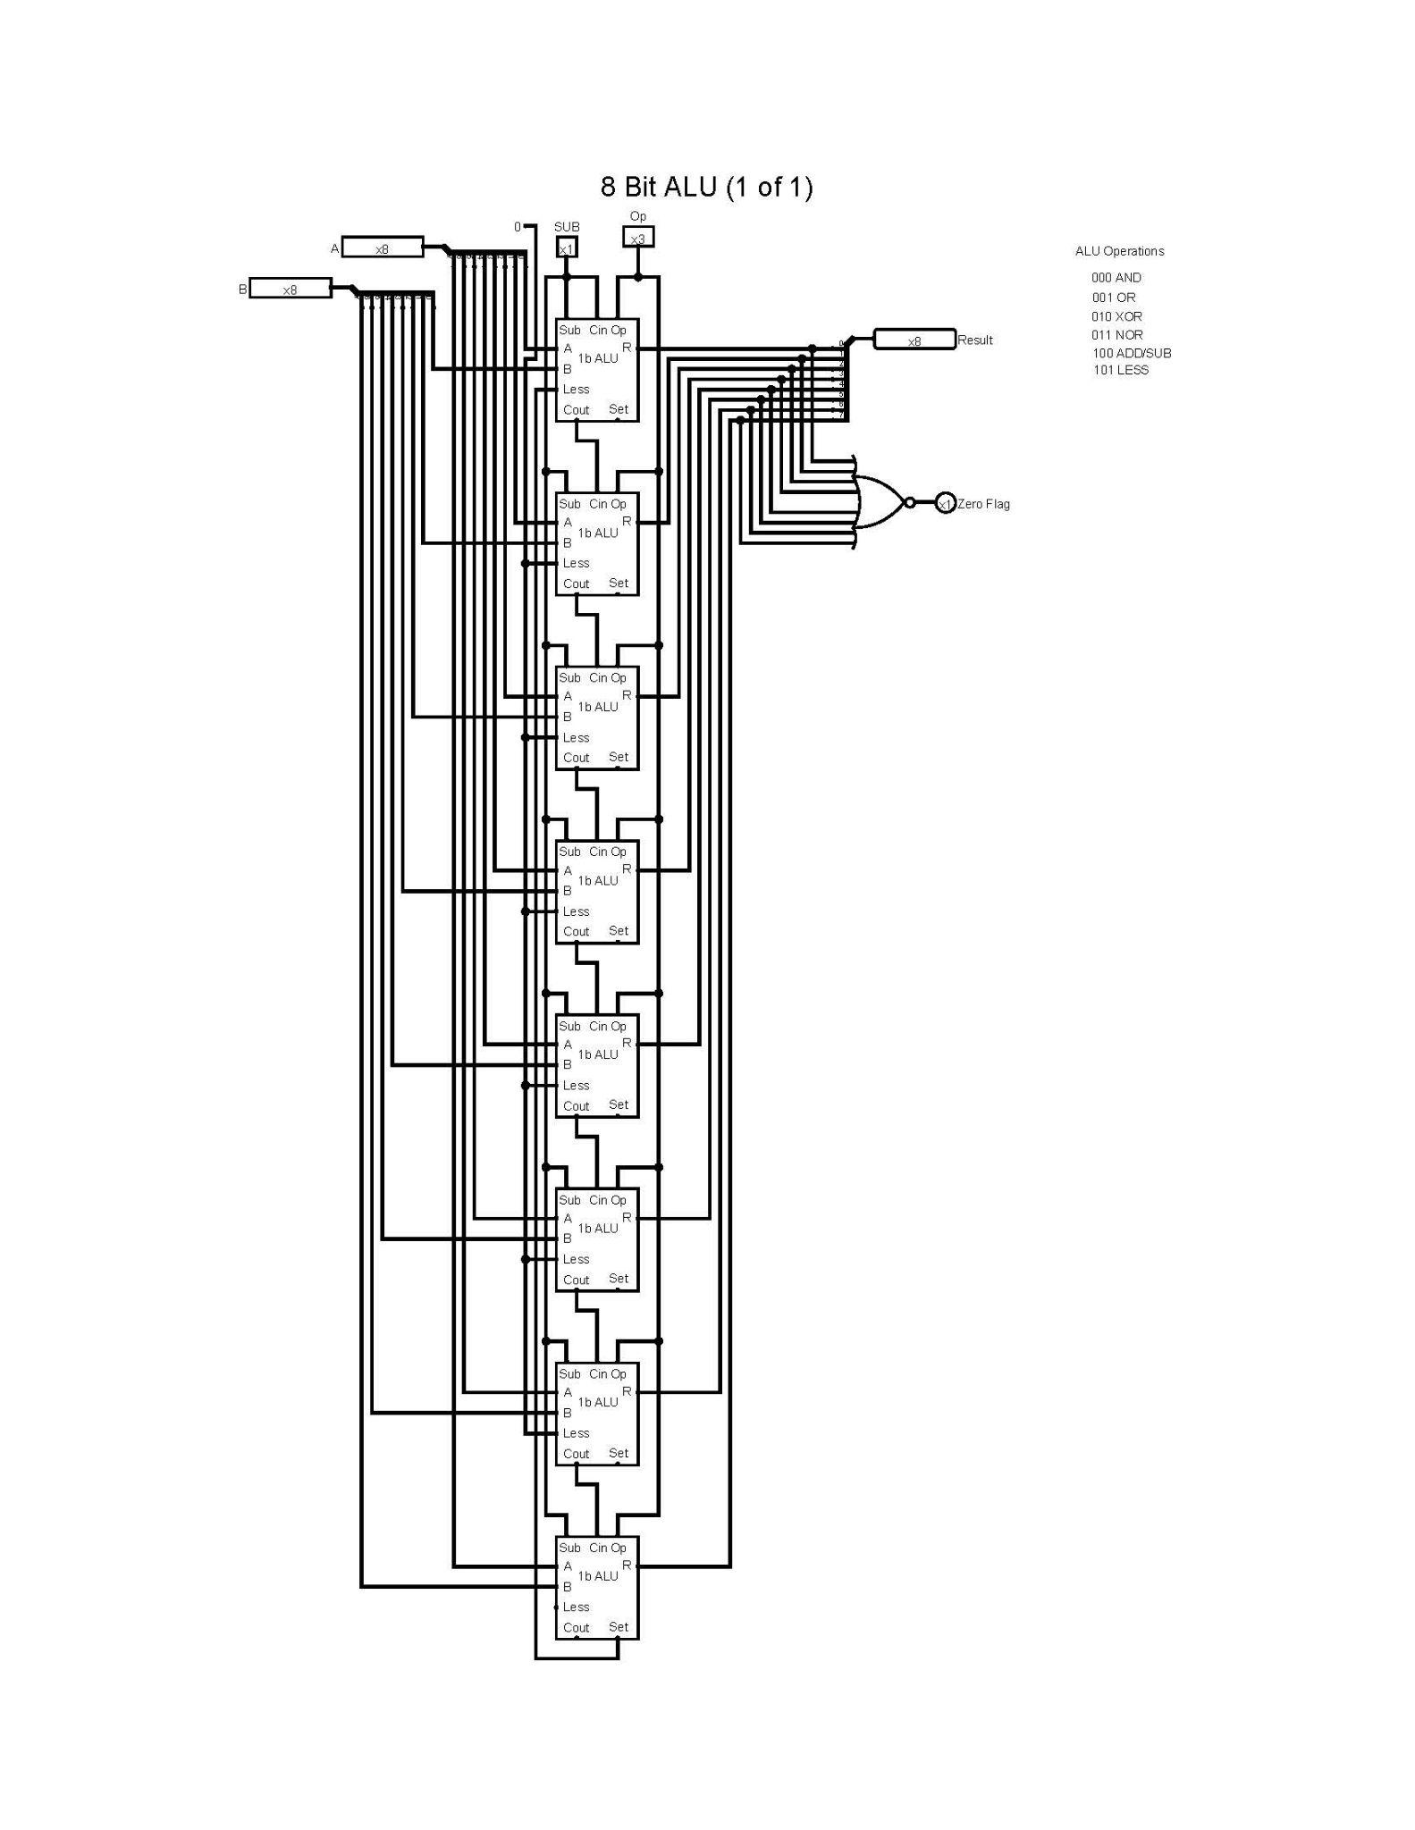

**Figure of 8-Bit ALU From LOGISIM File**

**Registers A Circuit Schematic**:

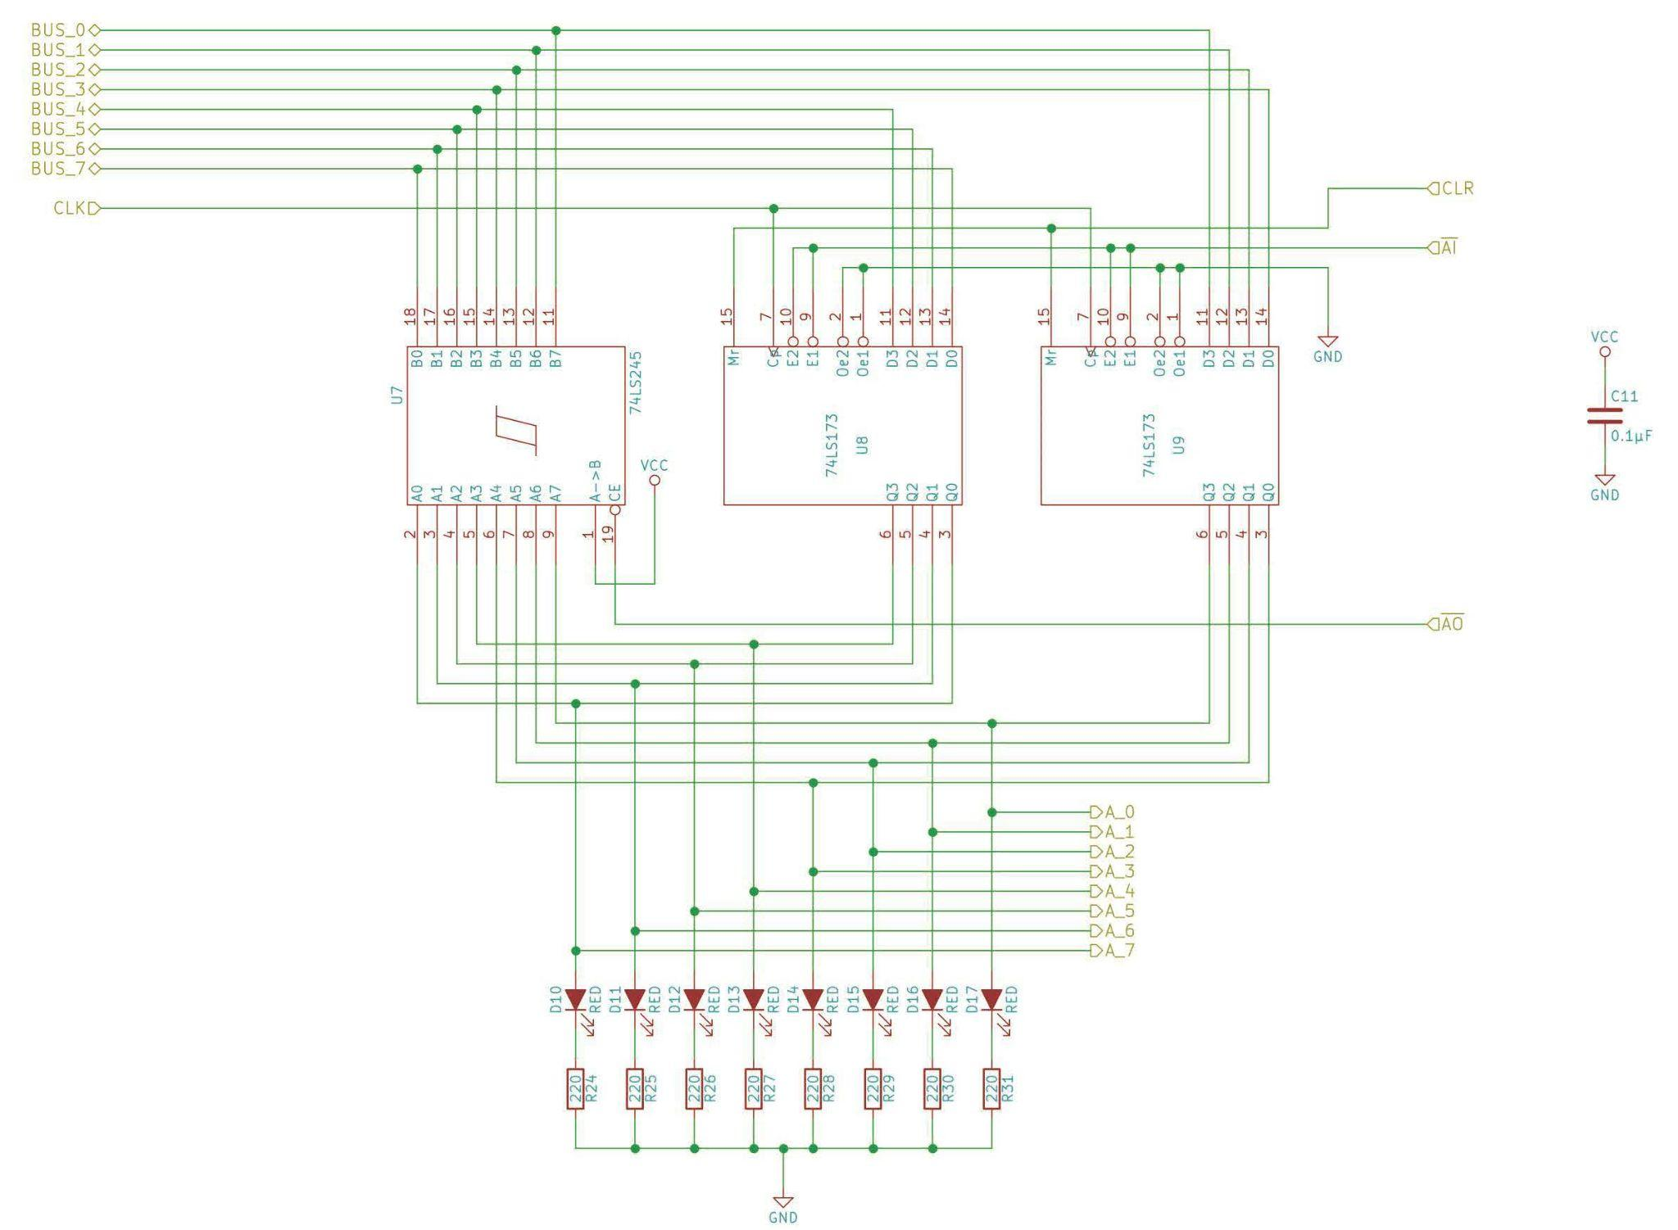

**Registers A Parts List:**

| A Register Module: | | | | | |
| --- | --- | --- | --- | --- | --- |
|  | QN | QIn | **DigiKey Part Number** | **Description** | **Alternate Part** |
|  | 1 |  | 1988-1060-ND | Breadboard |  |
|  | 2 |  | 296-33970-5-ND | [74LS173 4-bit D register](https://eater.net/datasheets/74ls173.pdf) |  |
|  | 1 | 5 | 296-1655-5-ND | 74LS245 (Octal bus transceiver) |  |
|  | 8 |  |  | 220Ω resistor |  |
|  | 8 | N |  | Red LED |  |
|  | 1 |  |  | 0.1µF capacitor |  |

**Registers B Circuit Schematic**:

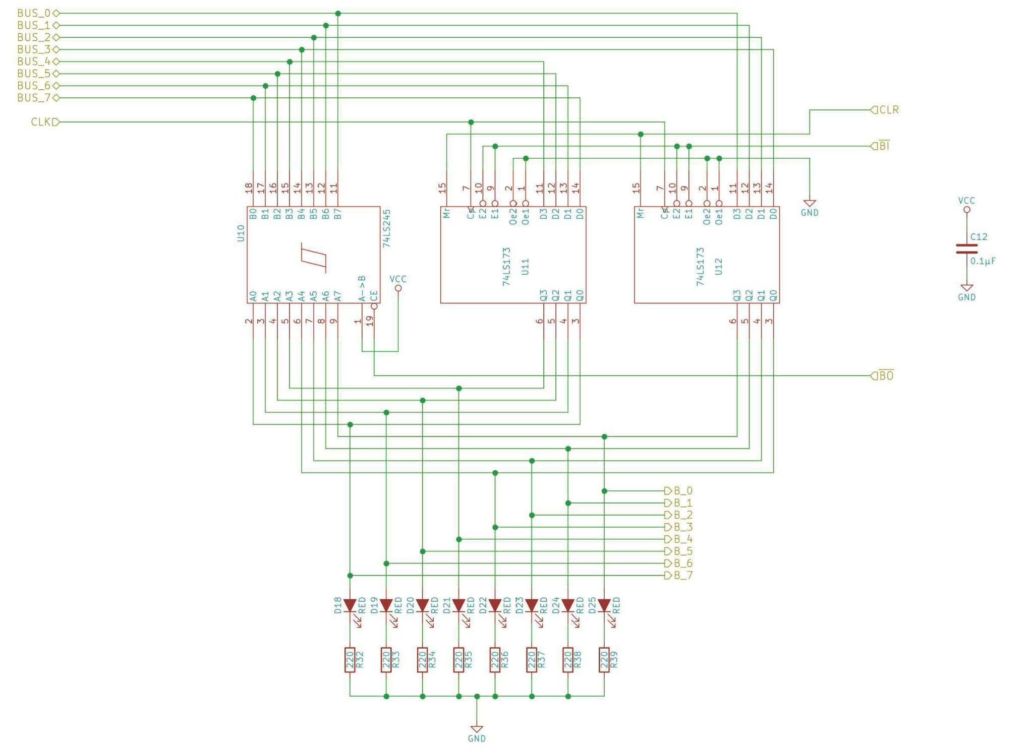

**Registers B Parts List:**

| B Register Module: | | | | | |
| --- | --- | --- | --- | --- | --- |
|  | QN | QIn | **DigiKey Part Number** | **Description** | **Alternate Part** |
|  | 1 |  | 1988-1060-ND | Breadboard |  |
|  | 2 |  | 296-33970-5-ND | [74LS173 4-bit D register](https://eater.net/datasheets/74ls173.pdf) |  |
|  | 1 | 5 | 296-1655-5-ND | 74LS245 (Octal bus transceiver) |  |
|  | 8 |  |  | 220Ω resistor |  |
|  | 8 | N |  | Red LED |  |
|  | 1 |  |  | 0.1µF capacitor |  |

**ALU Circuit Schematic**:

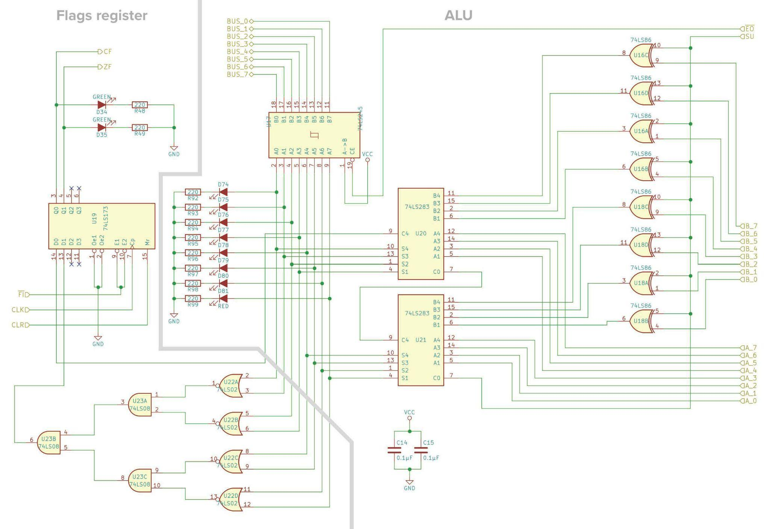

**ALU Parts List:**.

| ALU Module: | | | | | |
| --- | --- | --- | --- | --- | --- |
|  | QN | QIn | **DigiKey Part Number** | **Description** | **Alternate Part** |
|  | 1 |  | 1988-1060-ND | Breadboard |  |
|  | 2 |  | 296-1669-5-ND | [74LS86 Quad XOR gate](https://eater.net/datasheets/74ls86.pdf) |  |
|  | 1 |  | 296-1655-5-ND | [74LS245 Octal bus transceiver](https://eater.net/datasheets/74ls245.pdf) |  |
|  | 2 |  | 296-33987-5-ND | [74LS283 4-bit adder](https://eater.net/datasheets/74ls283.pdf) |  |
|  | 1 |  | 296-14874-2-ND  296-14874-1-ND  296-14874-6-ND | [74LS02 Quad NOR gate](https://eater.net/datasheets/74ls02.pdf) |  |
|  | 1 |  | 296-1633-5-ND | [74LS08 Quad AND gate](https://eater.net/datasheets/74ls08.pdf) |  |
|  | 1 |  | 296-33970-5-ND | [74LS173 4-bit D register](https://eater.net/datasheets/74ls173.pdf) |  |
|  | 10 |  |  | 220Ω resistor |  |
|  | 8 | N |  | Red LED |  |
|  | 2 | N |  | Green LED |  |
|  | 2 |  |  | 0.1µF capacitor |  |